**PARTS LIST**

TF-mini plus: lidar sensor

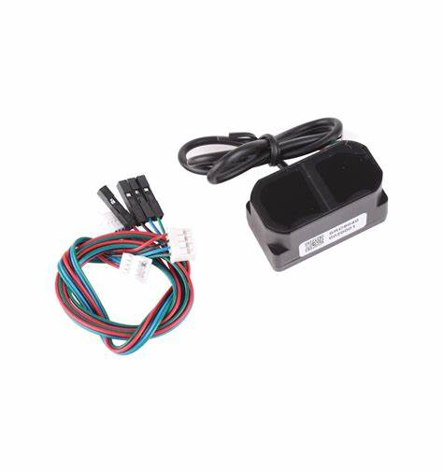

Esp32-wroom-32U   
(this specific module because it has a signal extension antenna)

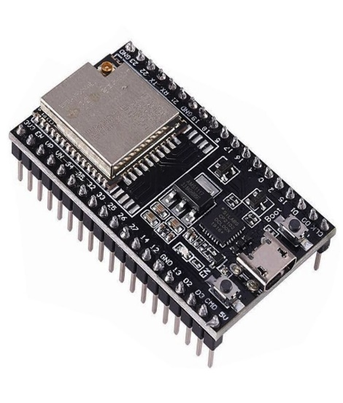

Two dc motor drivers I used the (L298N).

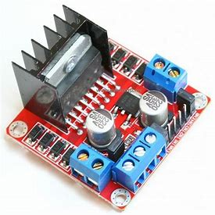

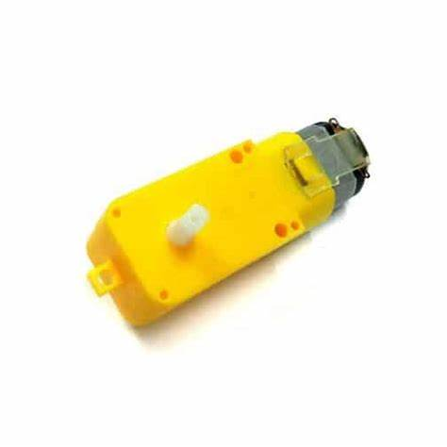Four dc motors (yellow tt-motors)

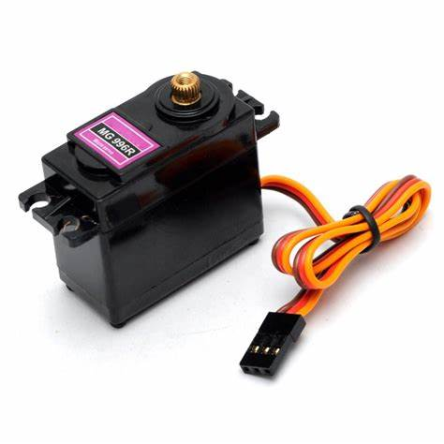4 servo motors (mg996r)

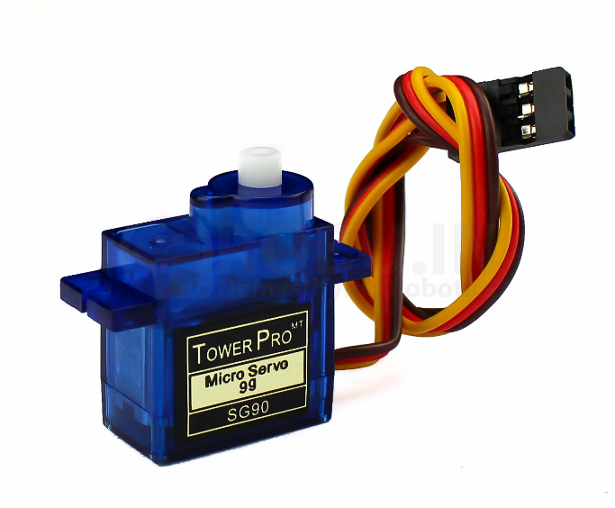2 smaller servo motors (sg90)

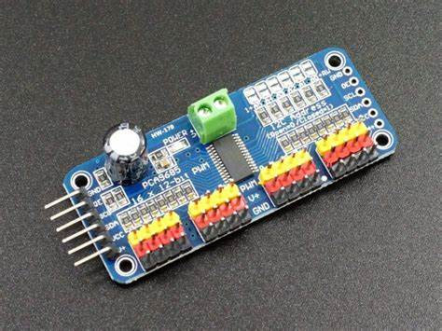

One 16-channel servo motor driver(PCA9685)